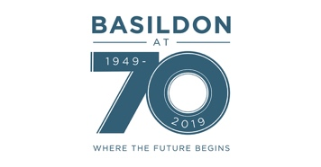
BASILDON SUPERSTARS
Searching for true sporting SUPERSTARS in Basildon Borough

Would you like to compete against sportsmen and women from Europe in a range of ten different sports over a weekend?

Are you available on Friday evening 20th September and throughout Saturday and Sunday 21st/22nd September to find the outstanding sports personality from the Basildon Borough?

As we celebrate the 70th anniversary of Basildon we are inviting 70 competitors in four different age groups and for both sexes. To add to the flavour of the event we will be joined by competitors from our twin towns in Germany and France.

Competition 1 Boys of Primary School Age 8 competitors
Competition 2 Girls of Primary School Age 8 competitors
Competition 3 Boys aged Under 14 (as at 21/09/19) 10 competitors
Competition 4 Girls aged Under 14 (as at 21/09/19) 10 competitors
Competition 5 Young men Under 18 (as at 21/09/19) 9 competitors
Competition 6 Young women Under 18 (as at 21/09/19) 9 competitors
Competition 7 Men over 18 (as at 21/09/19) 8 competitors
Competition 8 Women over 18 (as at 21/09/19) 8 competitors

Entry will be absolutely free, medals and trophies will be awarded in each Competition.

Entrants will compete in eleven sports over the weekend:
Archery, Football Penalty Shoot, Basketball challenge, 800/1500m run, Cricket Challenge, Gym Test, 25m swim, Cricket Ball throw, Long Jump, Cycle Challenge, Rowing Challenge.

Each competitor can opt out of one event or compete in all eleven and drop worst score.

Please get your expression of interest into the organisers by May 3rd 2019 as we expect fierce competition for places. The decision on who will be invited to compete will be taken by a panel. Successful applicants will be notified of their places by the end of May.

Entry is accepted from any resident of Basildon or someone connected to a Basildon
Borough based school or club. Our European guests will reside in Heiligenhaus, Germany or Meaux, France.

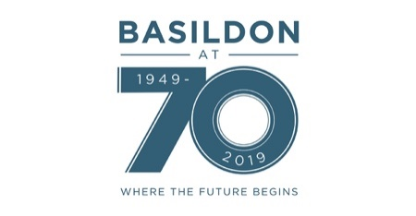
BASILDON SUPERSTARS
EXPRESSION OF INTEREST

Name: ………………………………………………………………………………………………………………………………..

Address: …………………………………………………………………………………………………………………………….

………………………………………………………….………………………………………………………………….

Postcode: ……………………………..

Date of Birth: ……………………………..

Email: ……………………………………………………………………………………………………………………………….

Telephone: ……………………………

School attended (if applicable): …………………………………………………………………………………………...

Club/s attended (if applicable): ………………………………………………………….…………………………………

………………………………………………………………………………………………………..…………………………..

What sports are you interested in?: …………………………………………………………….………………………..

……………………………………………………………………………………………………………..……………………………….

Entry will be absolutely free, medals and trophies will be awarded in each Competition.

Successful applicants will need to be available on the evening of Friday 20th September, Saturday 21st September and Sunday 22nd September.

Successful applicants will be notified of their places by the end of May.

Entry is accepted from any resident of Basildon or someone connected to a Basildon
Borough based school or club. Our European guests will reside in Heiligenhaus, Germany or Meaux, France.

For further information or to return your registration please email: sportstwin@outlook.com

Data Protection Disclaimer
What information is collected?
Date of birth, Full Name, email, Address, Telephone Number, Schools/Clubs attended
Where will it be stored?
Online via the Sportstwin email account and will not be shared or distributed to any outside third parties.
How long will it be stored for?
Data will be collected and stored until the date of the competition and it will then be securely destroyed.

